Project Planning Phase
Project Planning Template (Product Backlog, Sprint Planning, Stories, Story points)

Date | 29 June 2026
Team ID
Project Name | SB Stocks – Paper Trading Platform
Maximum Marks | 5 Marks

Product Backlog, Sprint Schedule, and Estimation (4 Marks)

Sprint | Functional Requirement (Epic) | User Story No. | User Story / Task | Story Points | Priority | Team Member
Sprint-1 | User Registration | USN-1 | As a user, I can register using my name, email, and password. | 2 | High | Thanusree
Sprint-1 | User Login | USN-2 | As a user, I can securely log in using my email and password. | 2 | High | Thanusree
Sprint-1 | Dashboard | USN-3 | As a user, I can view my dashboard showing balance, portfolio, and transaction summary. | 3 | High | Thanusree
Sprint-2 | View Stocks | USN-4 | As a user, I can view the list of available stocks with company details and prices. | 3 | High | Thanusree
Sprint-2 | Search Stocks | USN-5 | As a user, I can search stocks using company name or symbol. | 2 | Medium | Thanusree
Sprint-2 | Buy Stocks | USN-6 | As a user, I can purchase stocks using my virtual balance. | 5 | High | Thanusree
Sprint-3 | Portfolio | USN-7 | As a user, I can view all purchased stocks in my portfolio. | 3 | High | Thanusree
Sprint-3 | Sell Stocks | USN-8 | As a user, I can sell purchased stocks from my portfolio. | 4 | High | Thanusree
Sprint-3 | Transactions | USN-9 | As a user, I can view complete buy and sell transaction history. | 3 | High | Thanusree
Sprint-4 | Logout | USN-10 | As a user, I can securely log out of the application. | 1 | Medium | Thanusree
Sprint-4 | Deployment | USN-11 | As a developer, I can deploy the frontend on Vercel and backend on Render. | 2 | High | Thanusree

Project Tracker, Velocity & Burndown Chart: (4 Marks)
Sprint | Total Story Points | Duration | Sprint Start Date | Sprint End Date (Planned) | Story Points Completed (as on Planned End Date) | Sprint Release Date (Actual)
Sprint-1 | 7 | 2 Days | 25 Jun 2026 | 26 June 2026 | 7 | 26 June 2026
Sprint-2 | 10 | 2 Days | 27 June 2026 | 28 June 2026 | 10 | 28 June 2026
Sprint-3 | 10 | 2 Days | 29 June 2026 | 30 June 2026 | 10 | 30 June 2026
Sprint-4 | 3 | 2 Days | 1 July 2026 | 2 July 2026 | 3 | 2 July 2026

Total Story Points
30 Story Points

Velocity Calculation

Formula
Velocity = Total Story Points Completed ÷ Number of Sprints
- Total Story Points = 30
- Total Sprints = 4
Average Velocity = 30 ÷ 4 = 7.5 Story Points per Sprint

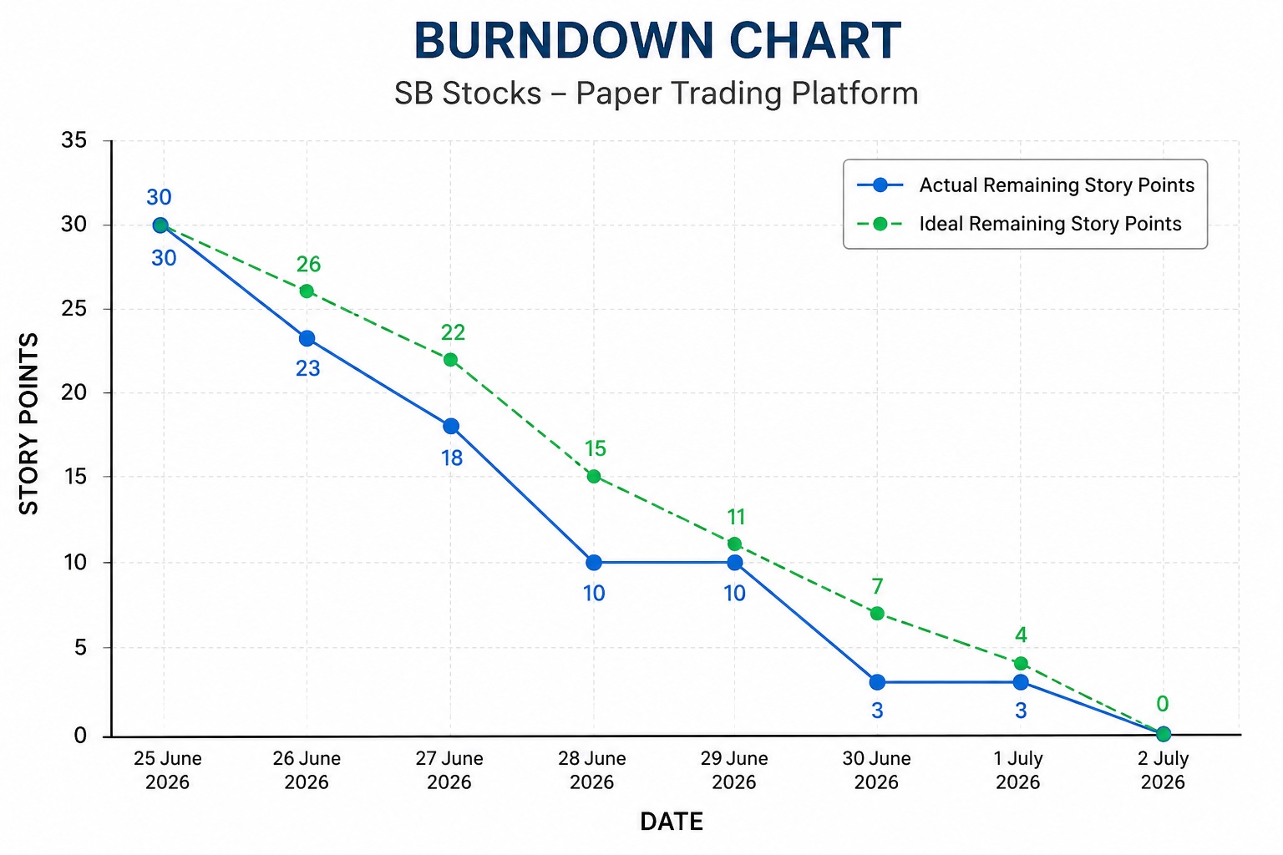

Date | Remaining Story Points
25 June 2026 | 30
26 June 2026 | 23
27 June 2026 | 18
28 June 2026 | 10
29 June 2026 | 10
30 June 2026 | 3
1 July 2026 | 3
2 July 2026 | 0

